TECHNICAL REVIEW:

Theoretical Bag Valve Mask Ventilator

# Terms and Definitions

Alveolar space – The region of the respiratory system that is composed of elastic, gas-permeable tissue that exchanges gas with the circulatory system.

Airways – The region of the respiratory system that carries gas from the mouth/nose to the alveolar space but does not participate in gas exchange.

Inspiratory time fraction – The portion of the breath time that is provided for inspiration.

Instrumental dead space – The volume of all the breathing system components that carry both inspiratory and expiratory gas.

Peak inspiratory pressure – The maximum airway pressure that occurs during an inspiratory cycle.

Respiratory rate – The number of breaths delivered per unit time.

Tidal volume – The volume inspired or expired in a single breath.

|  |  |
| --- | --- |
| Term | Definition |
| **BVM** | Bag valve mask |
| **CO2** | Carbon dioxide |
| **FDA** | Food and Drug Administration |
| **O2** | Oxygen |

# Theoretical Device Background

The most common manually operated breathing assistance device is the bag mask valve (BVM) which requires manual articulation and the full attention of a medical worker to ensure consistent operation. Additionally, owing to their manual nature, delivery of consistent ventilation is difficult with such devices. The theoretical device would aim to overcome these limitations by providing an automated assisted breathing device that is more accessible than current options and will free medical staff to perform other life-saving tasks. The theoretical device may or may not look something like the following (CRITICAL NOTE: THE PROPOSED THEORETICAL DEVICE WOULD COMPRESS/EXPAND THE BAG BASED ON TIMING ONLY, NOT SENSORS, WHICH EXPLAINS CERTAIN LIMITATIONS DESCRIBED BELOW):

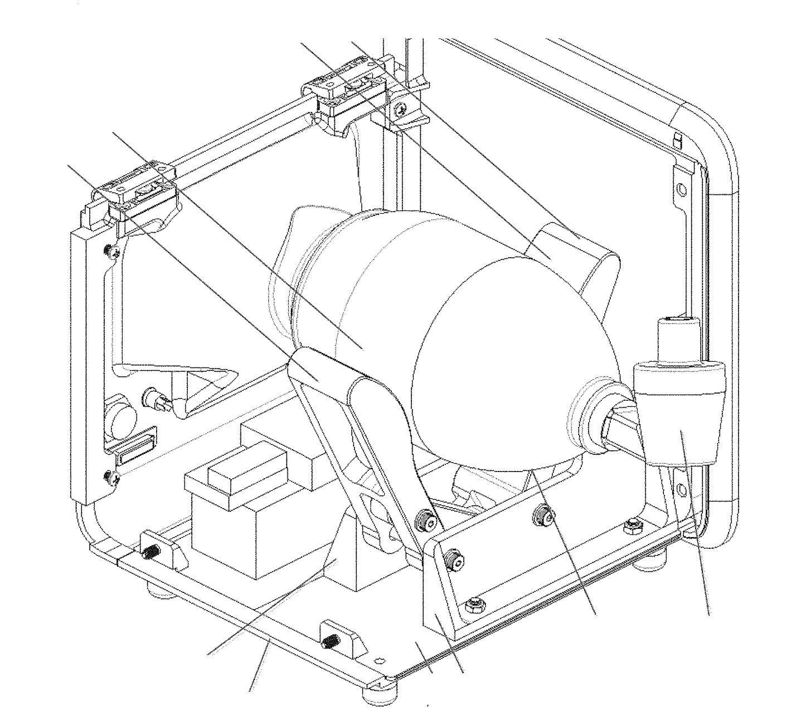

The target market for this product will be hospitals and medical institutions, particularly in resource limited settings. Additionally, if it is relatively compact and internally powered, the potential product will also be usable in emergency response and during patient transport.

# Key Relevant Standards

The following list represents a selection of key standards that should be reviewed and understood during early product development to help guide the design of the theoretical device. This list, however, is not exhaustive, and compliance with additional standards may be required for regulatory clearance that are either applicable to the specific design, features, or intended use of the product or to medical device development in general.

* IEC 60601-1 – Medical electrical equipment - Part 1: General requirements for basic safety and essential performance.
* IEC 60601-1-2 – Medical electrical equipment - Part 1-2: General requirements for basic safety and essential performance - Collateral Standard: Electromagnetic disturbances - Requirements and tests.
* IEC 60601-1-8 – Medical electrical equipment -- Part 1-8: General requirements for basic safety and essential performance -- Collateral standard: General requirements, tests and guidance for alarm systems in medical electrical equipment and medical electrical systems.
* EN 794-3 – Lung ventilators. Particular requirements for emergency and transport ventilators.
* ISO 10993-1 – Biological evaluation of medical devices -- Part 1: Evaluation and testing within a risk management process.
* IEC 62133 – Secondary cells and batteries containing alkaline or other non-acid electrolytes – Safety requirements for portable sealed secondary cells, and for batteries made from them, for use in portable applications.
* IEC 62304 – Medical device software -- Software life cycle processes.
* IEC 62366-1 – Medical devices -- Part 1: Application of usability engineering to medical devices.

# Technical Review of Limitations of Simple Approach

## Bag Valve Mask Overview

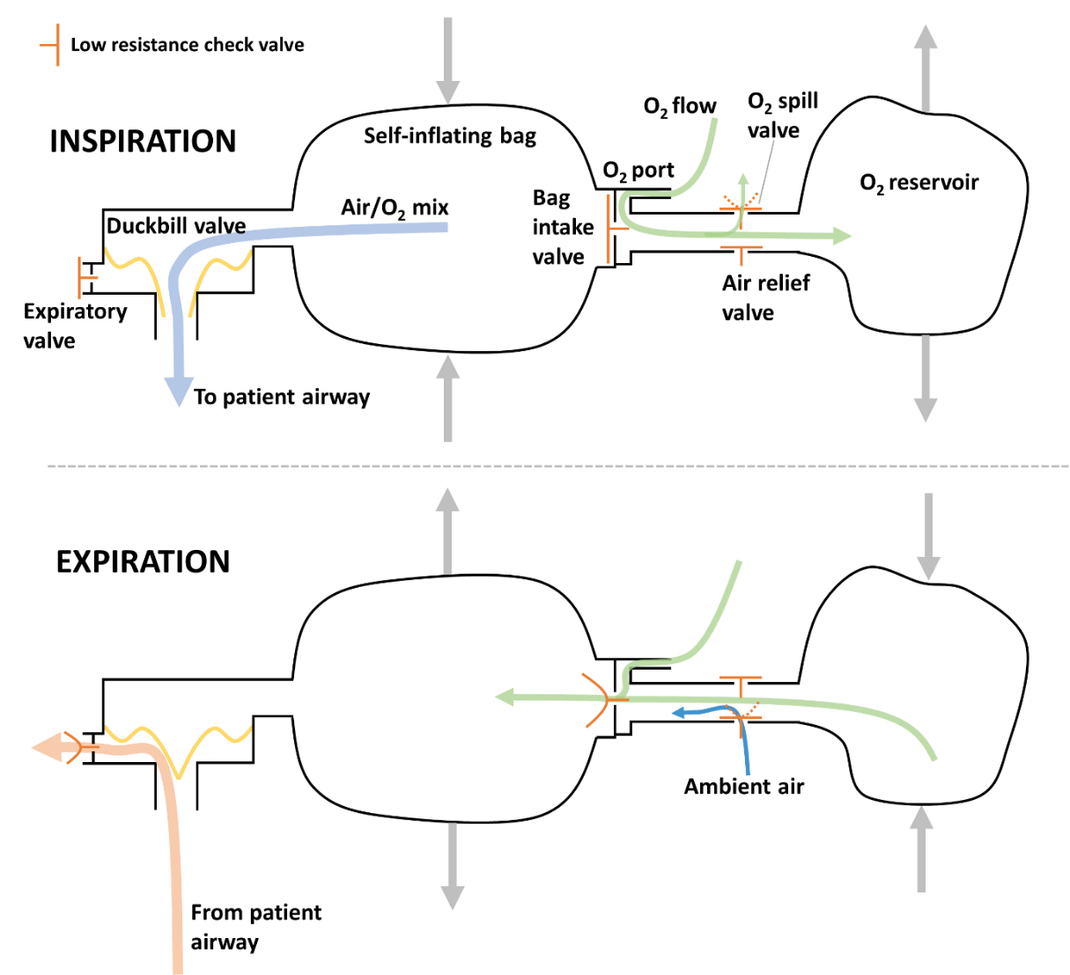

Figure 1: Schematic representation of a BVM

Figure 1 shows a schematic representation of a typical BVM. During inspiration, the self-inflating bag is compressed, generating a positive internal pressure. The positive pressure forces the bag intake valve closed and deforms the flaps of the duckbill valve to allow delivery of gas to the patient while simultaneously sealing the expiratory port/valve. Low pressure oxygen (O2) delivered through the O2 port is collected in an O2 reservoir; if the reservoir reaches capacity, excess O2 is released through the O2 spill valve.

During expiration, the self-inflating bag recoils to its uncompressed shape, generating a negative internal pressure. The negative pressure pulls the duckbill valve closed and draws O2 into the bag from the O2 reservoir. If the O2 reservoir is emptied, ambient air is entrained via the air relief valve. An annotated photograph of a commercially available BVM is shown in **Figure 2**.

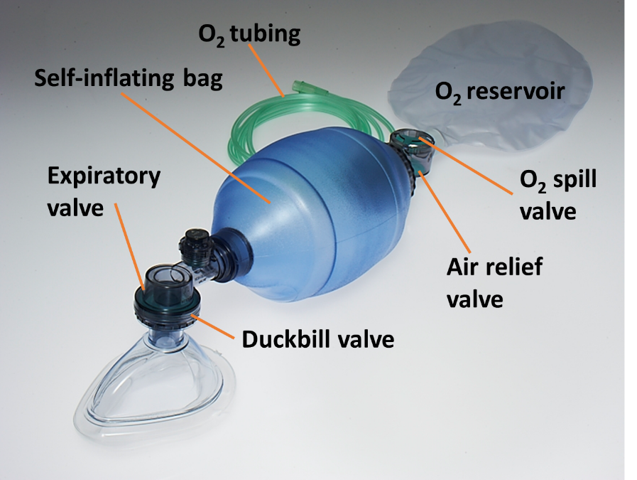

**Figure 2: Commercially available BVM**

## Dead Space

The role of the respiratory system is to deliver O2 to, and eliminate carbon dioxide (CO2) from, the circulatory system. In the simplest representation, the respiratory system consists of the airways and alveolar space (**Figure 3**, bottom). During inhalation, fresh gas containing high O2 and no CO2 is drawn, via the airways, into the alveolar space. The alveolar space is composed of highly gas-permeable tissue that is in close communication with the circulatory system. In this space, O2 diffuses from the lungs into the blood and CO2 from the blood into the lungs. During expiration, the low-O2, high-CO2 gas is expelled from the alveolar space via the airways.

The instrumental dead space of a breathing system is the combined volume of all the breathing circuit components that carry both inspiratory and expiratory gas. As shown in **Figure 3**, any gas that is expired into the dead space of the circuit is subsequently re-inspired without being replaced with fresh inspiratory gas. Over multiple respiratory cycles, the dead space gas is continually depleted of O2, while the CO2 content continually rises. The physiological consequences of the instrumental dead space depend on its size relative to the tidal volume; in the worst case, no fresh gas reaches the alveoli.

For the theoretical device, all the tubing connecting the outlet of the BVM to the patient airway is dead space. Most ventilator systems are set up with approximately 2 m of tubing with 22 mm internal diameter between the ventilator and the patient to facilitate convenient placement of the ventilator and provide a low resistance path for respiration. If this length of tubing was used with the theoretical device, it would contribute 760 ml of dead space to the system. This is well above the average adult tidal volume of 500 ml and, as a result, this configuration of the device would be unable to support life for most patients.

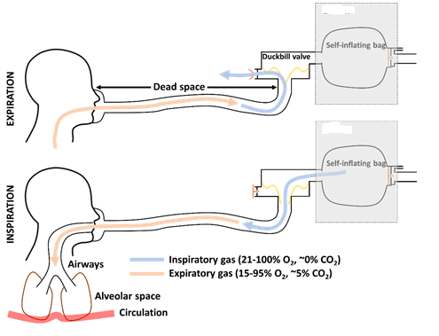

**Figure 3: Theoretical device dead space**

In general, it is advisable to limit instrumental dead space to less than 10 ml in adult patients and 5 ml for pediatrics. To maintain the overall “BVM in a box” concept and achieve this significant reduction in dead space, the duckbill/expiratory valve would have to be removed from the BVM and located at the patient airway (**Figure 4**). In our experience at IPD, this valve is not easily removable from most commercially available BVMs.

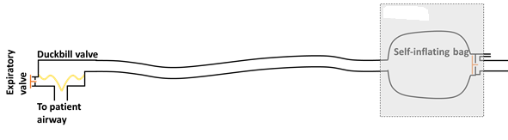

**Figure 4: Theoretical device with reduced dead space**

## Uncompensated Compliance

When delivering positive pressure ventilation, in any inspiratory cycle, the total volume of gas that enters the lungs is always less than the volume of gas that exits the ventilator. This is a result of two related properties of the system – the compressibility of gas and the compliance of the breathing circuit.

As gas exits the ventilator, and pressure within the system rises, the spacing between gas molecules decreases so that more gas molecules are stored per unit space. At the same time, the increase in pressure causes the ventilator tubing and other parts of the breathing circuit to expand and accommodate more gas compared to the start of inspiration. This gas, which doesn’t reach the patient, is commonly referred to as “lost” to the compliance of the system.

For the theoretical device specifically, the patient tidal volume will be lower than the volumetric compression of the BVM. This effect may be compounded by the significant volume and elastance of the self-inflating bag. As noted in section 4.2, the volume of 2 m of standard ventilator tubing is approximately 760 ml. As the volume of a typical adult BVM is 1500 ml, the total theoretical device breathing system volume is approximately 2260 ml. Similarly, the volumetric expansion of 22 mm ventilator tubing is approximately 0.5 ml/cmH2O/m8. Based on a conservative estimate for the BVM compliance of 0.5 ml/cmH2O, the total circuit compliance can be approximated as 1.5 ml/cmH2O.

The gas lost to the system can be calculated according to Equation 1, where *VL* is the lost volume, and *PIP*, *Patm*, *VC*, and *Cc* are the peak inspiratory pressure, atmospheric pressure, breathing circuit volume, and breathing circuit compliance, respectively. Using the above approximations for circuit volume and compliance, the percent error in volume delivery can been calculated for a standard adult and pediatric patient9 (Table 1).

Equation (1)

Table 1: Volumetric error due to circuit compliance

|  |  |  |
| --- | --- | --- |
| Parameter | Adult | Pediatric |
| Static lung compliance (ml/cmH2O) | 50 | 20 |
| Airway resistance (cmH2O/L/s) | 5 | 20 |
| Set tidal volume (ml) | 500 | 300 |
| Respiratory rate (breaths/min) | 10 | 20 |
| Inspiratory time fraction | 0.33 | 0.33 |
| PIP (cmH2O) | 11.3 | 21.1 |
| Lost volume (ml) | 41.5 | 77.7 |
| Delivered tidal volume (mL) | 458.5 | 222.3 |
| Error: Delivered vs Target (%) | 8.3 | 25.9 |

Note: Patm of 1 atm was used in the above calculations

A priori compensation for this error is difficult to implement because, as shown in Table 1, the error depends on the delivered respiratory profile and the respiratory mechanics of the patient. In addition, the error will vary with the volume and compliance of the breathing circuit that is used, which may change between patients. Lastly, the compliance of an individual breathing circuit may change with temperature and over time.

This limitation is overcome in existing ventilators by a number of different techniques. Most commonly, ventilators execute a circuit compliance check before each new patient and then dynamically measure the circuit pressure and correct the delivered volume in real-time throughout inspiration. Other ventilators may incorporate a flow sensor at the patient airway for monitoring the actual delivered tidal volume. Alternatively, most ventilators implement a pressure control mode wherein the ventilator targets a specific airway pressure instead of a tidal volume, and the control loop inherently compensates for any volumetric losses.

## Oxygen Delivery

As shown in Figure 1 and **Figure 2**, BVMs typically incorporate an O2 reservoir to collect O2 during compression of the self-inflating bag which is subsequently drawn into the system as the bag recoils. To achieve >95% O2 in the inspired gas9 the O2 reservoir should be large enough to accumulate at least one tidal volume. A bag of roughly 1 L should be sufficient for most patients. Based on IPD’s current understanding and review, the theoretical device does not contemplate the attachment of an O2 reservoir and associated relief valves. While provision of O2 without a reservoir will increase the inspired O2 fraction, the utilization of the supplied O2 will be inferior to the reservoir approach. For example, using a standard adult patient with a tidal volume of 500 ml, respiratory rate of 10 breaths/min, and inspiratory time fraction of 0.33, a flow of 5 L/min of O2 would result in ~100% inspired oxygen fraction with a reservoir; without a reservoir, the inspired oxygen fraction would be 73%. Addition of an O2 reservoir to the current design would require that the reservoir be placed externally, and a means provided to prevent unintentional compression (ex. a cage). Alternatively, the reservoir could be incorporated inside the theoretical device but would likely require an increase in product size to accommodate the additional volume.

## Respiratory Rate

The respiratory rate achievable with the theoretical device will be limited by the rate at which the self-inflating bag re-inflates after compression. Although adult respiratory rates (~10 breaths/min) may be easily achievable, pediatric respiratory rates (20+ breaths/min) may be difficult to achieve with an adult sized bag. In normal practise, BVMs are available in various sizes to accommodate adults, pediatrics, and neonates, where the recoil rate of each type of bag is sufficient to achieve the respiratory rates required for the intended patient population. The theoretical device may contemplate the addition of loops and hooks to the bag/compression system to allow for pulling the bag during expiration. Although this solution is viable, it would require a custom BVM to implement.

## Variations in Bag Valve Masks

The size and shape of BVMs is not standardized between products. If the theoretical product volume delivery is calibrated to a particular BVM, substitution of the BVM with a product with different geometry could lead to very significant errors in volume delivery. Additionally, the theoretical device structure would need to accommodate BVMs of varying shapes and sizes.

# Considerations for Addressing Limitations

## Parameters, Features, and Modes

Although the adjustable parameters, features, and available modes of ventilation differ significantly between ventilators, there is a subset of functionality that is common to many ventilators, including emergency and transport ventilators. The following is a list of some common functions that may be difficult to implement on the proposed theoretical device:

**Inspiratory/expiratory timing** – Although the theoretical device can vary respiratory rate based on the motor speed, it may be desirable to adjust the portion of the breath time that is allocated to inspiration and expiration separately. This would require sensing and feedback of the position of the compression mechanism to determine when the self-inflating back is being compressed (inspiration) and expanded (expiration), and adjustment of the motor speed during each phase appropriately. If this is not feasible, it is recommended that the device implement the most common inspiratory time to expiratory time ratio of 1:2, respectively. In general, it is unnecessary to control the rate at which the bag re-inflates and may be preferable to have the compression mechanism retract as quickly as possible after inspiration is complete.

**Triggering/cycling** – Triggering and cycling refer to the criteria for initiating and stopping inspiration, respectively10. The current concept of the theoretical device is both time-triggered and time-cycled. In many cases, it is beneficial to trigger or cycle a breath based on a patient signal. For example, patients do not always require full ventilatory support and may make weak and/or intermittent efforts to breath spontaneously. In this case, the ventilator may support spontaneous inspiratory efforts by detecting negative airway pressures and triggering a ventilator assisted breath. Similarly, a very high airway pressure during inspiration may indicate that the patient is trying to expire against the ventilator and the breath should be cycled. With the simple theoretical device, the motion of the compression mechanism is fixed. Implementation of any trigger or cycle conditions other than time may be very difficult as these features generally require near instantaneous switching between inspiration and expiration.

**Pressure controlled ventilation** – Most modern ventilators include a pressure control mode wherein the ventilator delivers a specific airway pressure profile instead of delivering a set tidal volume. Pressure control has many advantages over volume control, including automatic compensation for volume loss (compliance, leaks, etc.) and adjustment to changes in the patient’s respiratory mechanics. This mode, however, generally requires that the airway pressure be sensed and fed back to the ventilator gas source so that the airway pressure adheres to the setpoint. The bag/compression system in the current design may be unable to respond to changes in airway pressure with sufficient speed to implement this mode.

## Key Safety Features

The following list provides a high-level summary of some of the most important safety requirements included in standard EN 794-3 (Lung ventilators - Part 3: Particular requirements for emergency and transport ventilators). Although it is not a complete list of all safety requirements, it is intended to highlight some of the most critical safety features to consider during design of the theoretical device. Some of these features may already be incorporated into the BVM, which can be checked by cross-referencing standard ISO 10651-4 (Lung ventilators – Part 4: Particular requirements for operator-powered resuscitators).

* During power failure, the resistance at the patient connection port to inspiratory and expiratory flows shall not exceed 0.6 kPa (6 cmH2O) at 30 l/min for adult use, 0.6 kPa at 15 l/min for paediatric use, and 0.6 kPa at 2.5 l/min for neonatal use.
* The inspiratory and expiratory resistance measured at the patient connection port shall, during spontaneous breathing and normal operation, not exceed 0.6 kPa (6 cmH2O) at 60 l/min for adult use, 30 l/min for paediatric use, and 5 l/min for neonatal use.
* The ventilator shall have a power failure alarm which activates a continuous visual signal or an auditory signal of at least 7 s duration if the internal or external, electrical or pneumatic, power supply falls below the values specified by the manufacturer.
* A high pressure alarm shall be provided. It shall activate an auditory signal when the inspiratory pressure alarm level is reached.
* The system pressure shall be limited to less than 6.6 kPa (66 cmH2O), i.e. 6.0 kPa + 10 % during normal use.
* The maximum achievable pressure at the patient connection port under single fault condition shall not exceed 10 kPa (100 cmH2O).
* Means shall be provided to prevent or indicate hypoventilation due to inadvertent reduction in inspiratory flow.
* An emergency air intake port shall be provided and shall not accept any connector complying with EN 1281-1 and EN 1281-2. The emergency air intake port should be designed so that it cannot easily be obstructed when the ventilator is in use.

# Alternative Concepts

## Anesthetic Circle System Ventilator

Inhalational volatile anesthetics are the most commonly used type of anesthetic during surgery. However, they have low solubility in the blood, so most of the anesthetic inhaled by the patient is subsequently exhaled. Anesthetic circle systems are type of ventilator system that are designed to reuse the patient’s exhaled gas to conserve anesthetic. A typical anesthetic circle system is shown in **Figure 5** below.

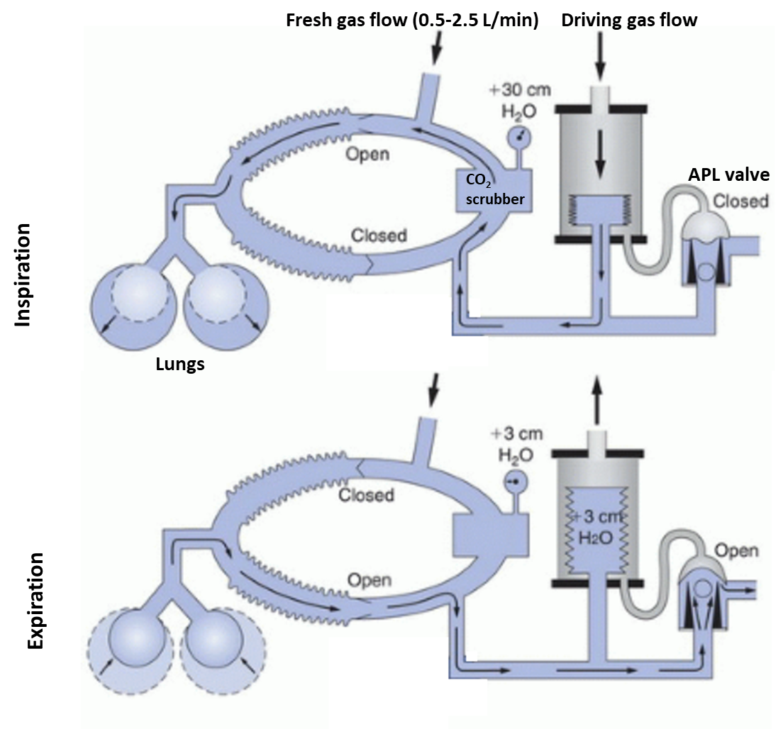

**Figure 5: Anesthetic Circle System**

During inspiration, a driving gas flow enters a rigid container with a collapsible bellows, causing the bellows to collapse and deliver gas to the patient. During exhalation, the expired has is directed back into the bellows allowing it to re-inflate.

The APL valve contains a flexible seal that, during inspiration, is forced down by the pressure of the driving gas, sealing the circuit. During expiration, the APL valve is released, allowing any expired gas in excess of the bellows volume to leave the circuit. A slight resistance in the APL valve, represented by the floating ball, ensures that during inspiration the pressure on the topside of the seal is greater than on the bottom side, causing the valve to close; during expiration, the resistance ensures that bellows fills preferentially before expired gas is released from the circuit.

The patient rebreathes previously exhaled gas which, normally, has low O2 content and high CO2 content. This is enabled by two features. Firstly, there is a CO2 scrubber in the circuit which removes CO2 from the expired gas. Secondly, a small flow of high O2 fresh gas is continuously delivered into the circuit which replenishes the oxygen supply, carries the anesthetic, and tops up any volume removed by the scrubber or lost due to leaks in the circuit.

Not shown in **Figure 5** is the ventilator controller which sets the rate, flow, and pressure of the driving gas to achieve the desired ventilation profile. Title volume is usually set by either by a movable mechanical stop in the bellows container that limits the maximum height the bellows reaches on inflation or by adjusting the inspiratory time and inspiratory flow.

### Relevance to the Theoretical Device

The ventilator portion of an anesthetic circle system (bellows, controller) is a fairly simple design, and available from many manufacturers in a variety of sizes with a variety of different features (**Figure 6**). Starting from one of these platforms may allow you to accelerate development. They often include basic rate and flow/volume controls, in addition to high and low pressure alarms. There are also companies that offer OEM versions of such ventilators11 that would provide a very good base to begin development.

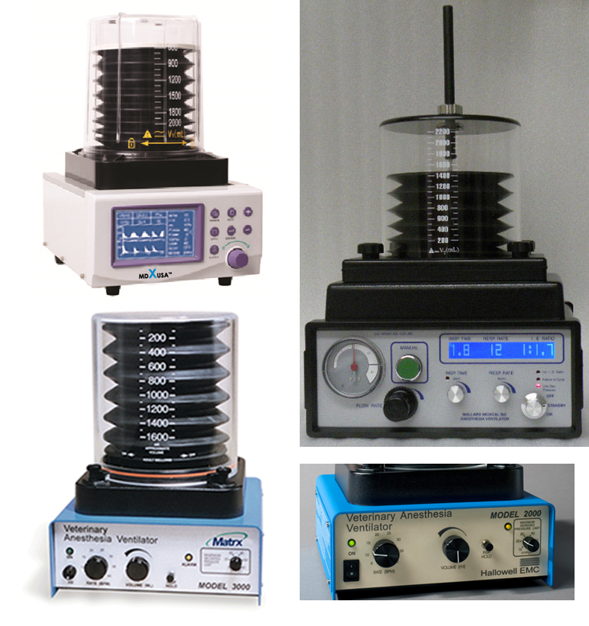

**Figure 6: Various bellows ventilators**

### Challenges and Potential Solutions

The primary challenge with modifying a circle system ventilator is reinflation of the bellows. In the typical use scenario, this is accomplished by the patient’s expired gas with the appropriate scrubbers and fresh gas flows to allow for rebreathing. Without these elements, using a traditional circle system is not feasible. A potential modification to the standard circle system ventilator setup to overcome this challenge is shown in **Figure 7** below.

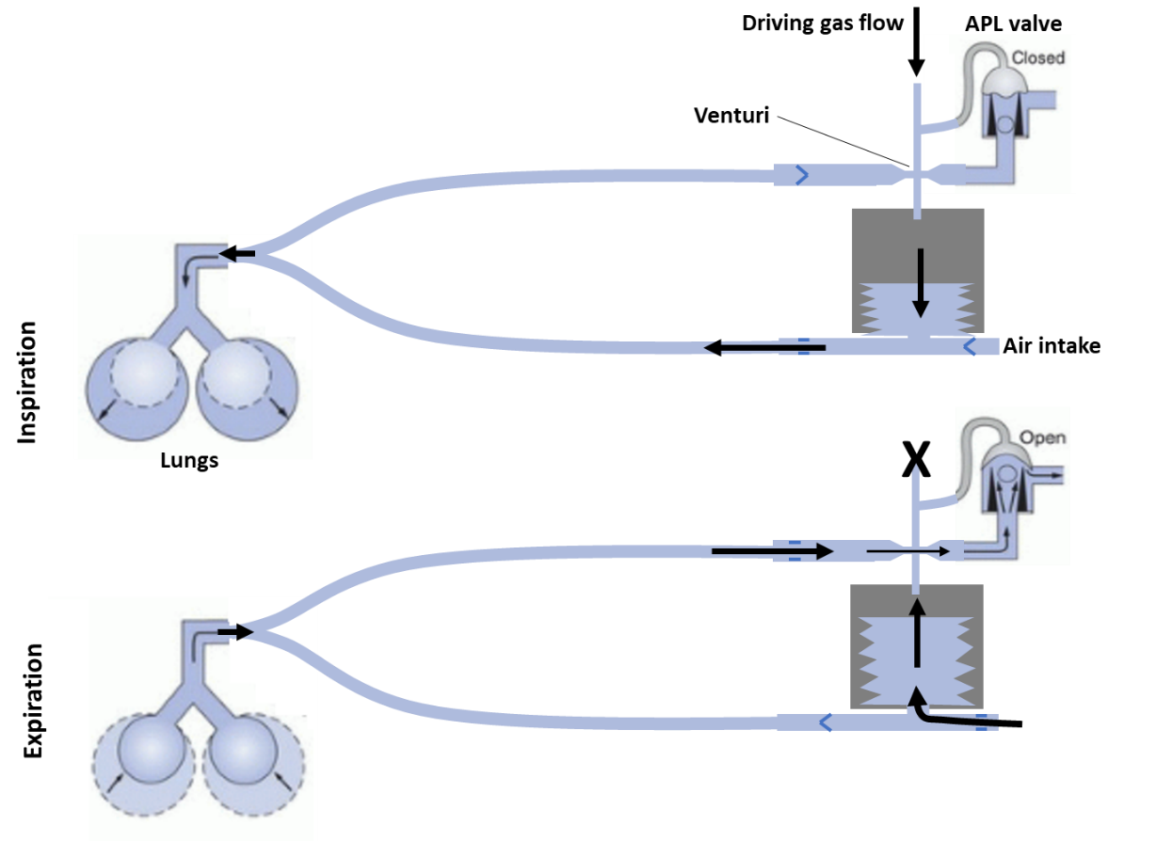

**Figure 7: Modified circle system for bellows reinflation**

In this configuration, during inspiration, the flow patterns are the same as the standard configuration – a driving gas compresses the bellows which delivers gas to the patient. During expiration, the driving gas is shut off, the APL valve opens, and the patient exhales out the APL valve through a Venturi tube. As gas passes through the narrow throat section of the Venturi, its velocity increases and, based on conservation of energy, its static pressure decreases. A venturi can be designed so that as gas passes through the throat, the pressure within the throat decreases below the ambient barometric pressure. This forms the basis of the well-known Venturi pump. By connecting the throat section of the Venturi to the bellows container, the patient’s exhaled gas may generate suction which causes the bellows to rise and draw in ambient air for the next inspiratory cycle.

### Critique

The use of a circle system ventilator may provide a simple platform to begin development of the theoretical device. Many models are available from many manufacturers, including some which supply OEM components. It is also aligned with the “bag-in-a-box” approach. However, circle systems were designed for a specific use case – ventilation during surgery where reuse of the patient’s exhaled gas is important for conserving inhalational anesthetics – and may require significant modification for more general use where a CO2 scrubber and fresh gas flow is not available or desired.

The concept shown in **Figure 7** is a potential solution to reinflation of the bellows without rebreathing. It has the advantage that it uses the kinetic energy of the gas molecules in the expiratory flow to provide suction and draw in ambient air, potentially decreasing power consumption and increasing battery life. However, the velocity of exhaled gas may be insufficient to generate enough suction, and experimentation would be required. In addition, any leaks between the patient and Venturi will reduce the flow through the Venturi and reinflation of the bellows.

More obvious solutions to the problem include using a bellows which self-inflates during exhalation (like a BVM); switching the driving gas between the bellows container and air intake port during inspiration and expiration, respectively; or using a reversable source of driving gas that can provide positive pressure and negative pressure to the bellows container during inspiration and expiration, respectively. A mechanical driving force, such as a linear motor, can also be used. These solutions will be more robust, but less power-efficient.

### Existing Technology

We are currently unaware of any products that use a Venturi tube to reinflate a ventilator bellows, as shown in **Figure 7**. However, our search was not exhaustive, and should you decide to pursue this idea, we recommend a thorough intellectual property search by a qualified professional.

Other respiratory devices that use the Venturi principle include:

* Venturi oxygen masks (Intersurgical Ltd., 1040090)
* Venturi percussive ventilators (Hill-Rom, MetaNeb)
* Ventilators with Venturi tubes on the inspiratory limb for entrainment/mixing of gases12

# References

1. United States Food and Drug Administration. General Controls for Medical Devices. Available at: https://www.fda.gov/MedicalDevices/DeviceRegulationandGuidance/Overview/GeneralandSpecialControls/ucm055910.htm. (Accessed: 25th February 2018)

2. United States Food and Drug Administration. Classify Your Medical Device. Available at: https://www.fda.gov/MedicalDevices/DeviceRegulationandGuidance/Overview/ClassifyYourDevice/ucm2005371.htm. (Accessed: 5th March 2018)

3. United States Code of Federal Regulations. *Definitions. 21 CFR §860.3.* (2018).

4. United States Food and Drug Administration. *FDA and Industry Procedures for Section 513(g) Requests for Information Under the Federal Food, Drug, and Cosmetic Act. Guidance for Industry and Food and Drug Administration Staff.* (2012).

5. United States Code of Federal Regulations. Powered emergency ventilator. 21 CFR §868.5925. (2018).

6. United States Food and Drug Administration. *The 510(k) Program: Evaluating Substantial Equivalence in Premarket Notifications [510(k)]. Guidance for Industry and Food and Drug Administration Staff.* (2014).

7. United States Food and Drug Administration. 510(k) Premarket Notification Database. Available at: https://www.accessdata.fda.gov/scripts/cdrh/cfdocs/cfPMN/pmn.cfm. (Accessed: 20th March 2018)

8. GE Healthcare. *Breathing Systems. iBreathe custom configured breathing circuit kits. Doc No: DOC1460178.* (2013).

9. European Committee for Standardization. *EN 794-3:1998+A2:2009. Lung ventilators - Part 3: Particular requirements for emergency and transport ventilators.* (2009).

10. Chatburn, R. L., El-Khatib, M. & Mireles-Cabodevila, E. A taxonomy for mechanical ventilation: 10 fundamental maxims. *Respir. Care* **59,** 1747–63 (2014).

11. Penlon. Original Equipment Supplier. Available at: http://www.penlon.com/en/us/products/oem.html. (Accessed: 16th May 2018)

12. Jain, R. K. & Swaminathan, S. Anaesthesia ventilators. *Indian J. Anaesth.* **57,** 525–32 (2013).